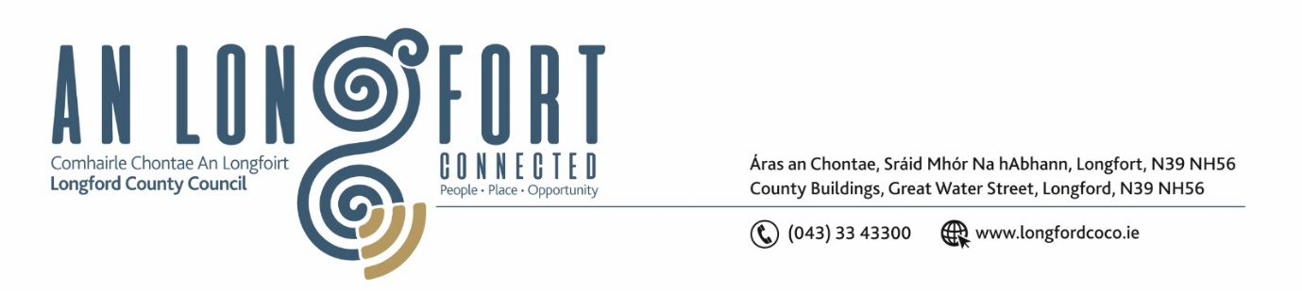**LONGFORD MUNICIPAL DISTRICT**

**Minutes of Meeting of Longford Municipal District held in the Council Chamber Aras an Chontae and via MS Teams on Wednesday, 22 February 2023 at 3.30pm**

**CATHAOIRLEACH**: Councillor Gerry Hagan

**MEMBERS PRESENT**: Councillors – Martin Monaghan, Uruemu Adejinmi, John Browne, Seamus Butler, Peggy Nolan and Gerry Warnock

**IN ATTENDANCE**: Mr. John Brannigan, Director of Services

Mr. Eamonn Bennett, Senior Executive Engineer

Ms. Lorraine Mc Kee, Administrative Officer

Mr. Brian Faughnan, Executive Engineer

Mr. Richard Smith, Senior Executive Architect

**MEETINGS**

**ADMINISTRATOR:**  Ms. Claire McNabola

**APOLOGIES:**  None

1. **ADOPTION OF MINUTES – circulated**

On the proposal of Councillor Peggy Nolan seconded by Councillor Martin Monaghan it was unanimously agreed to adopt Minutes of Meeting of Longford Municipal District held on the 25 January 2023.

1. **MATTERS ARISING FROM MINUTES**

None.

1. **DECLARATION OF INTEREST BY MEMBERS**

Councillor Seamus Butler declared his interest in St Patrick’s Day parade due to his membership in Longford Chamber of Commerce

1. **MANAGEMENT REPORT - circulated**

The Management Report, as circulated, was noted.

Senior Executive Engineer Eamonn Bennett responded to questions on the following:

* Traffic lights at the Longford Arms/Richmond Street
* Ongoing works at Leo Casey Roundabout
* Works around Market Square
* Roundabout from Battery Road onto Lisbrack Road

1. **REVIEW OF BY-LAWS**

A review of (Street Service Vehicles) Bye Laws is currently underway, it is hoped to have draft bye laws in place for consideration at the April Longford MD Meeting, - ahead of the public consultation process. Any items for consideration in respect of these draft bye laws being prepared can be directed to [mmcgrath@longfordcoco.ie](mailto:mmcgrath@longfordcoco.ie).

1. **LONGFORD GREYHOUND TRACK PROJECT UPDATE**

Senior Executive Architect Richard Smith provided the Members with an update on the Longford Greyhound Track project.

Following the approval of a Part 8 proposal in November 2022, funding of €405,000 was announced for this project from the Department of Rural and Community Development.

In February 2023 – ‘Design and Build’ for Skatepark only advertised on eTenders, with closing date March 2022 and award the week thereafter. Q4 2023 – Skatepark planned for completion.

Potential for wider Part 8 site to accommodate 100m long pump-track and 700 m2 special needs playground – funding dependent.

Richard responded to questions on:

* Proposed connection to the Royal Canal Greenway
* Development of a pump track on the site
* Development of an FAI approved soccer pitch on the site
* Consideration of a ‘master plan’ to create a long-term strategy for the future use of the amenity area

1. **UPDATE ON RECOMMENDED MINIMUM CRITERIA FOR ENVIRONMENTAL INSPECTION (RMCEI)**

Noted - The Environment Section will share the 2023 RMCEI Plan as soon as it has been approved by the Director of Services and I will be happy to address any queries on the matter after that.

1. **ST. PATRICK’S DAY PARADE 2023**

On the proposal of Councillor Gerry Warnock and seconded by Councillor John Browne, it was unanimously agreed to provide €7,500 towards the organising of the St. Patrick’s Day Parade 2023.

Councillor Peggy Nolan requested that the Chamber of Commerce, who oversee the planning of the St. Patrick’s Day Parade in Longford, would engage with the Longford County Council Arts Office with regards the participation and involvement of community groups throughout the county in the annual parade.

1. **NOTICES OF MOTIONS, SUBMITTED BY COUNCILLORS:**

**The following notice of motion was proposed by Councillor Gerry Warnock and seconded by Councillor Peggy Nolan**

I am calling on Longford Municipal District to commence the process for the formal “Taking in Charge” of the infrastructural roads, public lighting and storm water services at Palace Crescent, Ardnacassa, Longford.

**Response**

Longford County Council are already in charge of the public lighting at Palace Crescent. I carried out an inspection on the road at Palace Crescent and I have no objections to Longford County Council taking in charge the road, storm drainage and footpaths. However, the actual process in this case is to declare the road a public road under the Roads Act and not the “taking in charge” of this road which comes under the planning legislation.

**The following notice of motion was proposed by Councillor John Browne and seconded by Councillor Martin MonaghanLongf**

In the interest of Public Safety, I call on Longford County Council to have Public Lighting installed between the Leo Casey Roundabout and the Red Cow Roundabout.

**Response**

The provision of Public Lighting along this section of the N4 will be subject to agreement with and provision of funding from the TII. Longford County Council Road Design Section will engage with the TII in relation to this proposal and will progress the necessary justification reports when resources permit.

This concluded the business of the meeting.

**Signed: ____________________**

**Claire McNabola,**

**Meetings Administrator.**

**Confirmed and adopted at Longford Municipal District Meeting held on the 22 March 2023.**

**Signed: _______________**

**Cathaoirleach.**